**Good Practice in Manufacturing Horse Feeds and Supplements**

The following information sets out how producers of horse feed and supplements manufacture to the highest standards of feed safety and quality. The guide also explains some of the other terms and approval marks that manufacturers may choose to use to indicate a feed or supplement’s suitability for particular situations.

**Feed Assurance Schemes**

These are voluntary schemes that manufacturers sign up to as they are an independent indicator of a high standard of feed safety. Companies are independently audited at least once a year and short notice spot checks are also conducted to ensure standards are maintained. The following schemes are the most common in the UK:

**UFAS** – Universal Feed Assurance Scheme. An independent quality scheme which annually audits feed manufacturers to ensure their products are made legally and to consistently high standards. Look for UFAS on compound feeds such as mixes, cubes, balancers, fibre blends and feed supplements.

**FEMAS** – Feed Materials Assurance Scheme. A sister audit to UFAS that covers single ingredient feed materials, such as oats, straight forages or salt licks. Producers of feeds with UFAS approval will largely be sourcing ingredients that have FEMAS approval to ensure safety throughout the supply chain.

**GMP+FSA** – A European feed audit for feeds sold across UK and Europe, equivalent to UFAS.

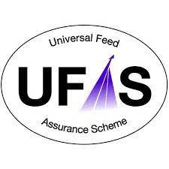 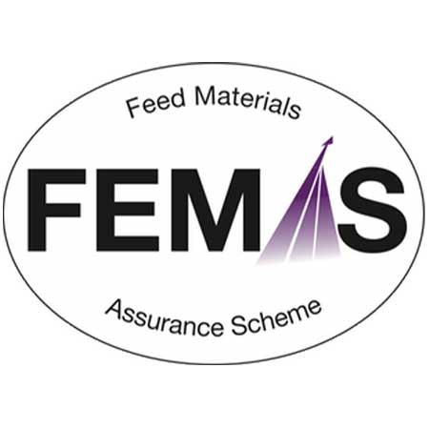 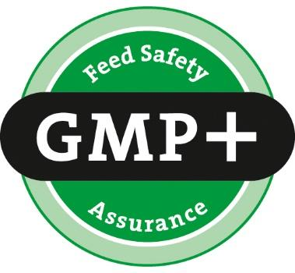

To check that the manufacturer of your horse’s feed is accredited to high standards, check for the UFAS, FEMAS or GMP+FSA logo on packaging. Each manufacturer will have their own unique number. That number may be incorporated alongside the UFAS logo but it is not a requirement to use the logo, so manufacturers may simply list the number with the audit scheme as shown in the images below

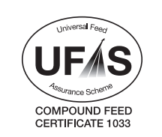 or 

Whichever format, the number should be legible to be read easily. Visit the auditor’s websites to check accreditation is correct and up to date.

**Trade Membership**

Membership of BETA (British Equestrian Trade Association) is optional for businesses, but is another indication a feed manufacturer is trustworthy and operating responsibly. BETA provides guidance, training and updates to members to help ensure they are meeting the requirements of Feed Law and producing good quality feed. Look for the following logo:

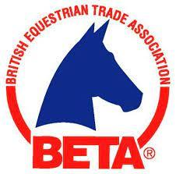

**Does your horse have a particular dietary need?**

Many health conditions require dietary adjustment and so it is important we choose appropriate feeds for those with specialist requirements. The following approval marks are indicators of feeds that are suitable for horses with specific diseases, however, it is very important to note the feeds do not treat, cure or prevent these diseases.

**Laminitis Trust Feed Approval Mark**

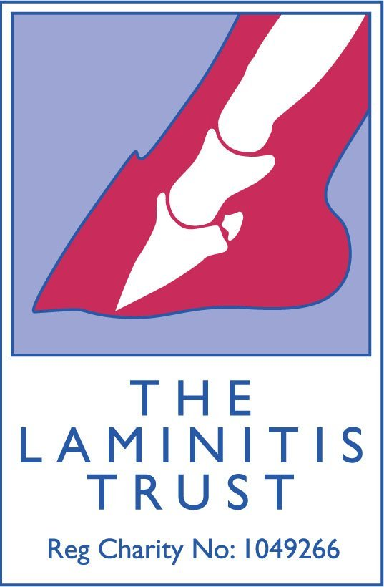

Run by The Laminitis Trust, this feed approval mark means the feed has been assessed to be a suitable formulation for those prone to laminitis. To qualify for the scheme, the feed must be capable of providing at least half of the horse or pony’s required daily energy, but with controlled levels of Non-Structural Carbohydrate (NSC) which is the combined amount of starch and sugar in a feed. Feeds with the Laminitis Trust approval must not exceed 0.25% of bodyweight in NSC per meal.

**BETA Approval mark for horses and ponies prone to Equine Gastric Ulcer Syndrome**

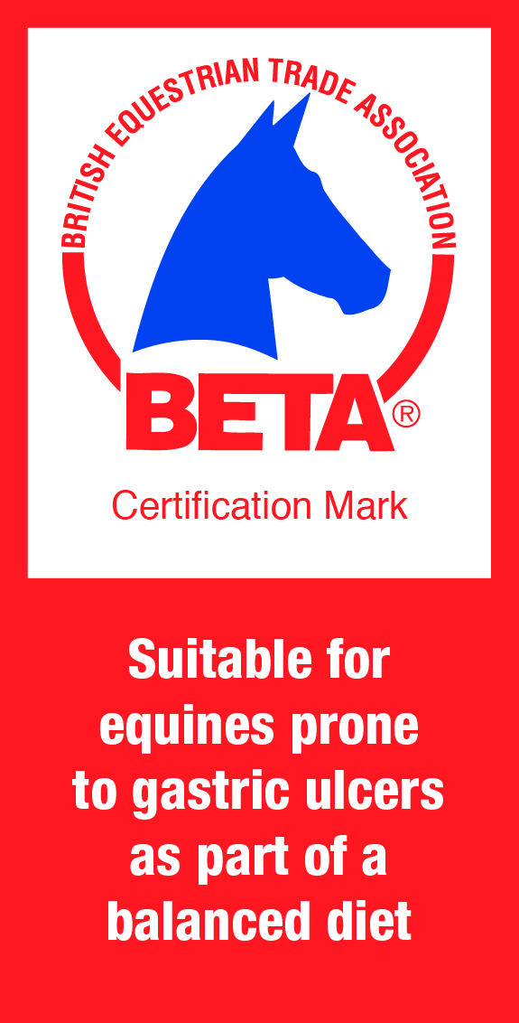

Run by BETA, the feed approval mark for horses prone to Equine Gastric Ulcer Syndrome (EGUS), is used for feeds which are either compound feeds designed to provide a balanced diet, or high fibre and alternative energy feeds, such as oils. For both categories of feed they must provide less than 1g sugar and starch per kilogram BW per meal, and less than 2g sugar and starch combined per kg BW per day. Any manufacturer can apply for approval with this mark.

Both schemes require products and marketing materials to be scrutinised by the Veterinary Medicines Directorate to promote best practice and to ensure that no misleading or medicinal claims are made. It is very important that products are recognised as helping to reduce the risk of disease not reducing the disease itself and so the scheme does not recognise ingredients or products that may purport to have health benefits. The schemes do not include concentrated feeds, such as supplements.

Both the Laminitis Trust and BETA EGUS marks aim to help horse owners to make suitable choices for their horse or pony.

**Competition Confidence**

BETA members may also choose to be BETA NOPS ® accredited. NOPS stands for Natural and Other Prohibited Substances and is a further level of quality audit (in addition to UFAS/ FEMAS) to help reduce the risk of accidental contamination with prohibited substances in animal feed.

When you consider that products which could produce a positive dope test under FEI rules are common in the horse’s environment – for example the list includes poppy seeds, hemp, chocolate or coffee - then you can see the need for high quality and stringent controls in the manufacturer of feed for equine athletes.

While no manufacturer can, or should, offer any form of guarantee – and to do so implies they don’t fully understand the risks – we do advise only choosing BETA NOPS Feed, including Feed Supplements, if competing under affiliated rules.

Whether you choose to compete or not, choosing the BETA NOPS mark is another way to ensure the feed has been produced to high standards.

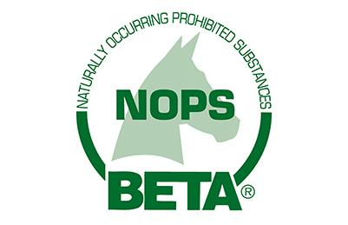

**Human grade – what does this mean?**

What does ‘Human grade’ really mean in your horse feed, including feed supplements? Probably, very little.

For a product to be labelled as ‘human grade’ the manufacturer should be licensed as a **Food** Producer with the local authority and preparing, producing or selling food for you and me. Without that authorization the product cannot be ‘human grade’. Conversely, animal feed producers and retailers must be registered with their local authority. A typical registration will look something like, for example, ‘Reg No. GB/562/R1811’ and should be detailed on all packaging.

Feed Hygiene regulations apply not only to the manufacturer but also those retailing feeds and supplements. Whether that is your local tack shop or feed merchant, an internet retailer, local farm shop or even your vet – if they are selling you feed, including supplements, they require a Feed Hygiene registration, so don’t be afraid to ask and check.

Always remember, animals have different nutritional needs to people, so purchasing human food for your horse is never advised especially if you are competing in affiliated competitions.

**What should I be aware of with products made abroad?**

With the growth of internet shopping there are more opportunities to potentially access products made abroad. It is very important to consider that products from different parts of the world are made under very different rules to those in the UK. In the UK and Europe, extensive legislation ensures that feed, including feed supplements, are safe and suitable for use in horses; in some parts of the world that legislation is lacking, or very different. There is also legislation controlling imports which is connected to product safety but also the potential to bring in pests and diseases if appropriate measures haven’t been taken. There is a good chance if products are made abroad they won’t get through our border control without a specific import license.

**Do different rules apply to supplements?**

It is a common misconception that horse feed supplements are not regulated, with a feeling that manufacturers can simply include what they like. Legally there is no such thing as a ‘supplement’ and they are considered, quite simply, as ‘Feed’. This means that supplement manufacturers work under all the same Feed Law legislation, which ensures their products are safe.